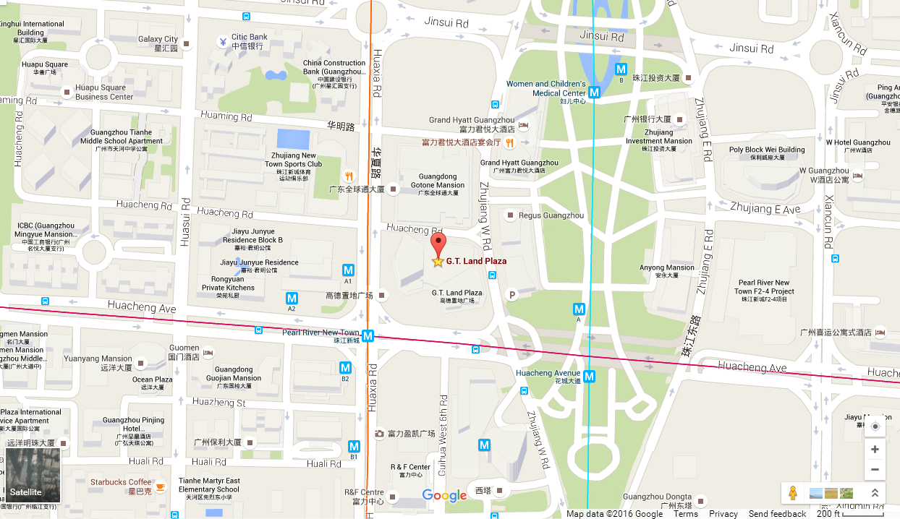

广州公司  Guangzhou Office | 广州市天河区珠江新城花城大道85号高德置地广场A座39楼, 510623  39/F, Tower A, G.T. Land Plaza, No. 85 Huacheng Avenue, Zhujiang New Town, Guangzhou 510623, P.R. China  Tel: 86-20-87323188, 87320276, 87326001, 87326002, 87323500, 87324800

